Analysing Smart City Bike Sharing Data using Power BI
1. Project Overview
This project involves cleaning, transforming, and analysing raw data and creating an interactive Power BI dashboard to derive meaningful business insights.
Objective
The main objective is to demonstrate data pre-processing techniques and an interactive Power BI dashboard visualization to make informed decisions.

2. Problem Statement
- Determine which cities have the highest System Imbalance Scores, indicating poor bike distribution efficiency.
- Pinpoint geographic clusters where stations are consistently "Critical: Empty" or "Critical: Full," preventing users from renting or returning bikes.
- Identify "outlier" stations where the number of stands significantly exceeds the number of available bikes, leading to wasted infrastructure.
- Use data to prioritize which cities require manual bike redistribution to move the network from a "Critical" state back to a "Balanced" state.

4. Attribute (Column /Features) Details:
Attribute Name | Data Type | Description
Station Number | Whole Number | Number for each Station
Station | Text | Name of each Station
Station Address | Text | Address of the Station
Latitude | Decimal Number | Latitude points of the location
Longitude | Decimal Number | Longitude points of the location
Banking | Text | On-site credit card payments
Bonus | Text | "Bonus" time or credits to users
Status | Text | Opened or closed status of the Station
City | Text | Station City
Bike Stands | Whole number | No. of bike stands in the Station
Available Bike Stands | Whole Number | No. of bike stands ready to park
Available bikes | Whole number | No. of bikes available to rent
Last update Date and Time | Date, Time | Records the exact date and time the station’s server last communicated its "Available Bikes" and "Stands" count to the central system.
Station Status | Text | Tells you whether a bike station is currently available for public use or restricted due to maintenance or system issues.
Station Size | Text | Groups stations based on their total physical capacity (Total Bike Stands).

5. Tools & Technologies
- Power BI: Data modelling, DAX calculations, visualization, and interactive dashboard creation.

6. Data Pre-Processing (Power Query)
Tasks Performed:
- Data Cleaning & Transformation: Handled missing values, standardized formats, and created calculated fields.
- Filtering & Sorting: Organized data to focus on relevant records.
- Convert the data into Fact and Dimension Table

- Separated the Name column with number to unique texts
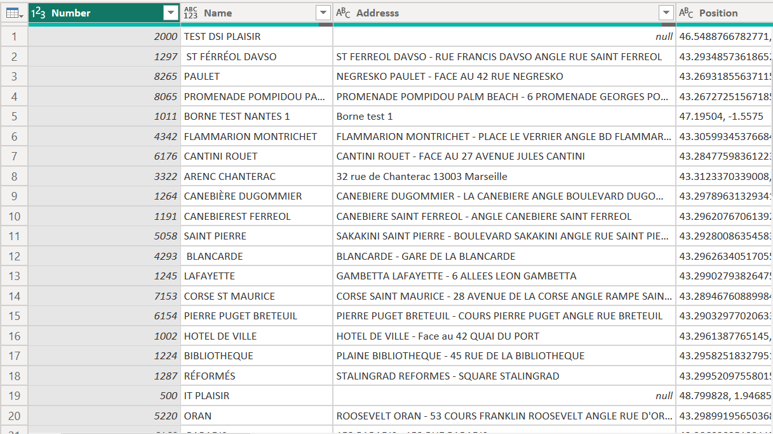
- Replaced the null values in address column with the names in Name column
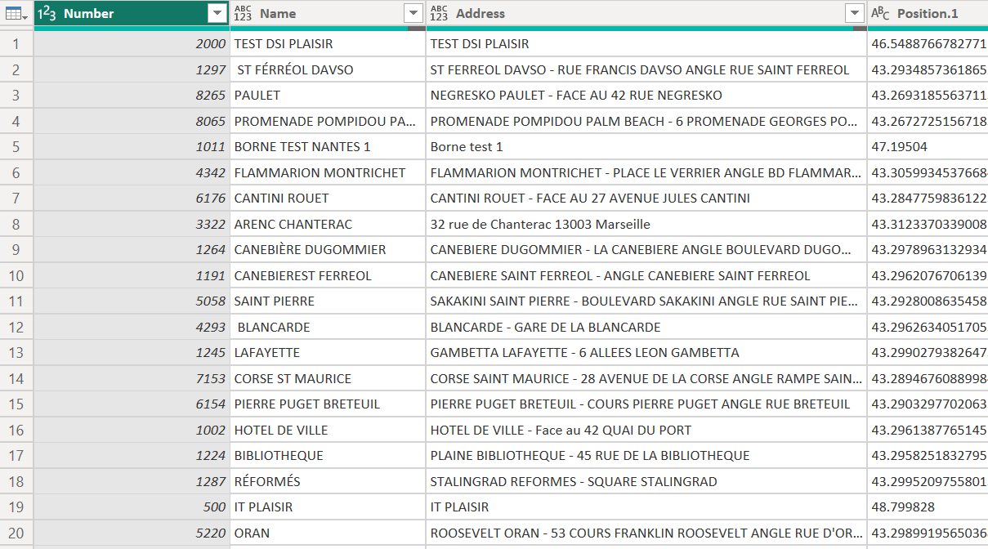

- Separated Latitude and Longitude column using Delimiter.
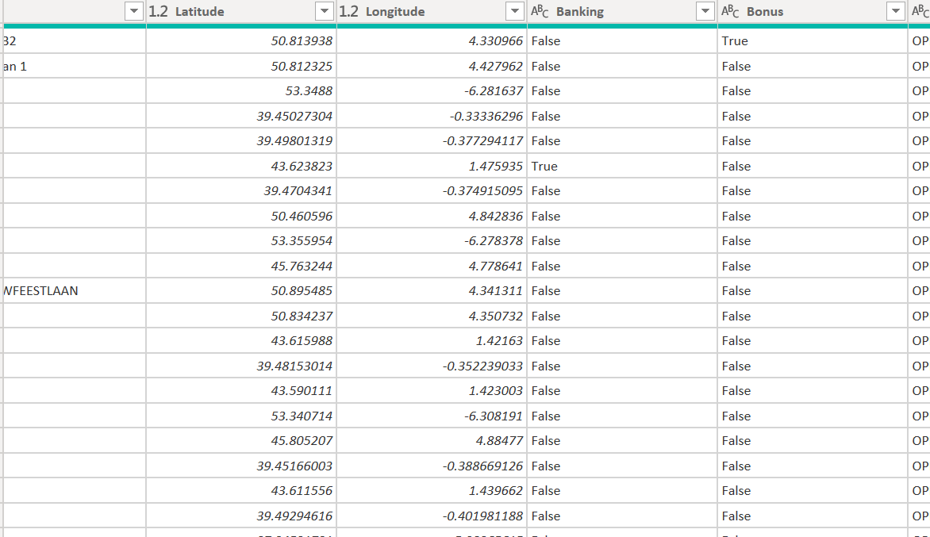

- Separated Date and Time using Delimiter
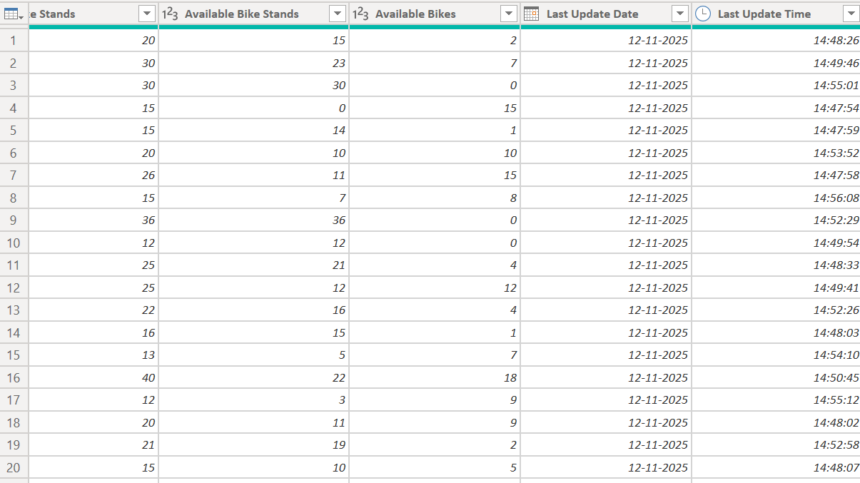
7. Data Modelling
- Data Model: Established relationships between tables and defined cardinality.
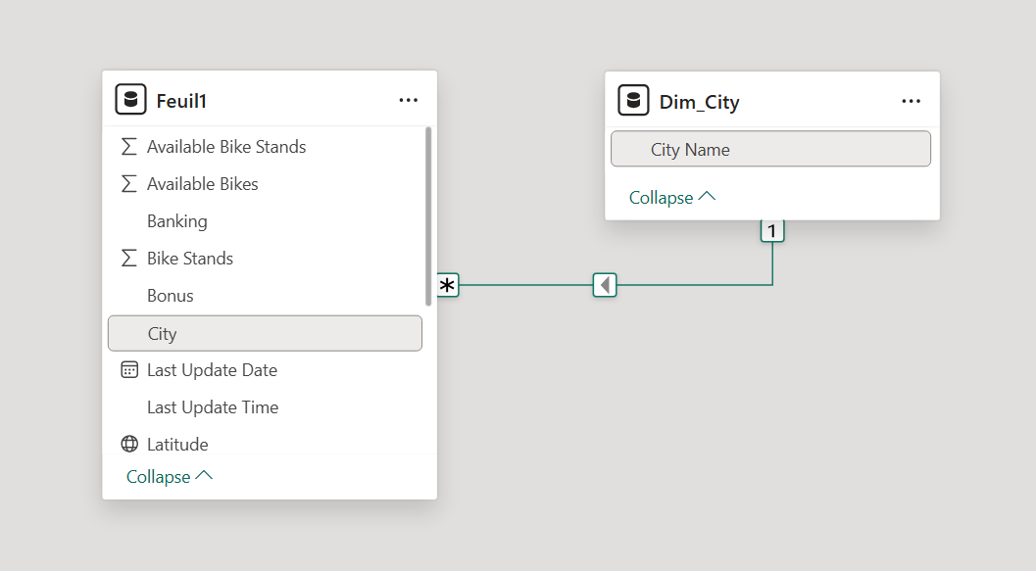
- Calculated Columns:
- Created Station Status column to check whether a bike station is currently available for public use or restricted due to maintenance or system issues.

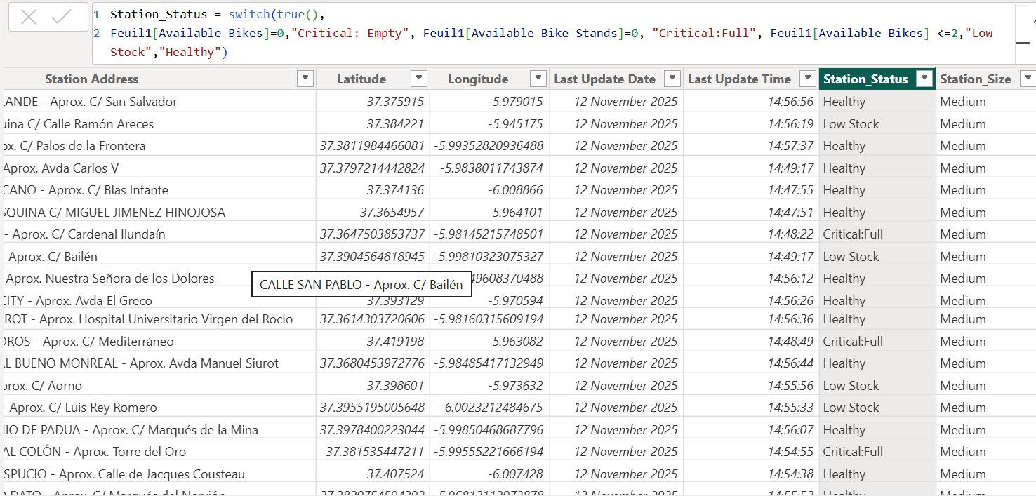
- Created Station size column to group stations based on their total physical capacity (Total Bike Stands).
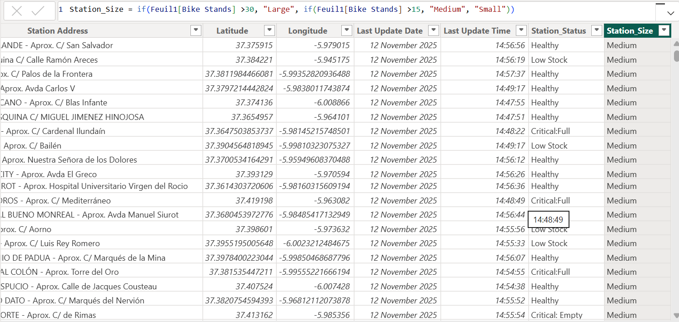
- DAX Measures:
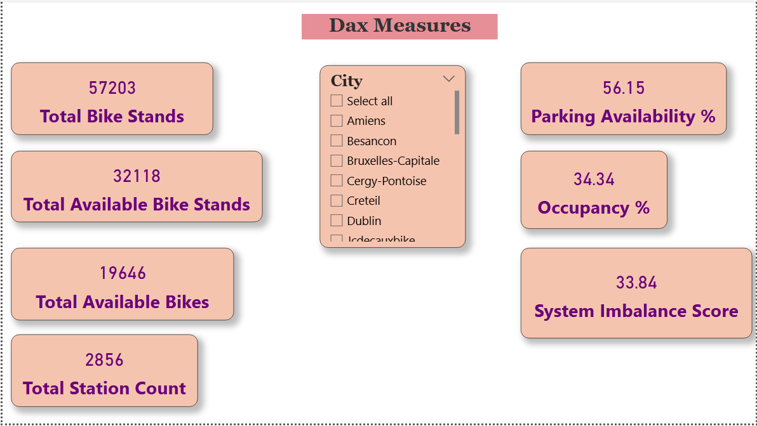
8. Analysis and Visualizations
Geographic Distribution of Station Status:
- The key insight from the Geographic Distribution of Station Status map is that system imbalance is highly localized, with significant "Critical: Empty" (red) and "Critical: Full" (orange) clusters across Europe.
- This reveals that cities like Seville and regions in France face severe service gaps, requiring targeted bike redistribution to move the network back to a "Healthy" green state.
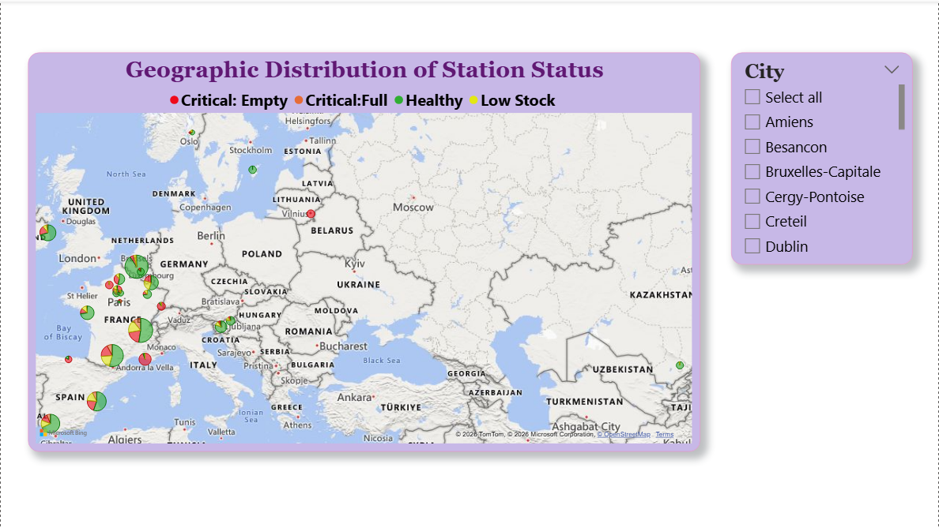
Station Status by Count of Stations:
- The Station Status by Count of Stations chart reveals that nearly 30% of the network is currently in a "Critical" state, with 24.68% (705 stations) being completely empty and unable to serve users.
- While over half the network remains "Healthy," the significant volume of empty and low-stock stations suggests a major need for bike redistribution to maintain service availability.
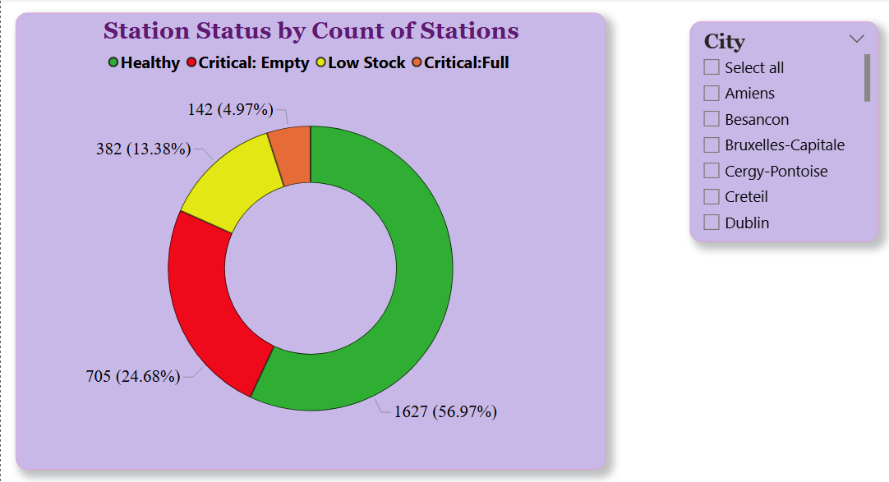
System Imbalance Score by City:
- The System Imbalance Score by City chart reveals a massive performance gap between contracts, with Jcdecauxbike (65) and Lund (53) being the most inefficient.
- In contrast, cities like Rouen, Vilnius, and Marseille maintain nearly perfect balance with scores between 0 and 2, setting the benchmark for operational excellence in the network.
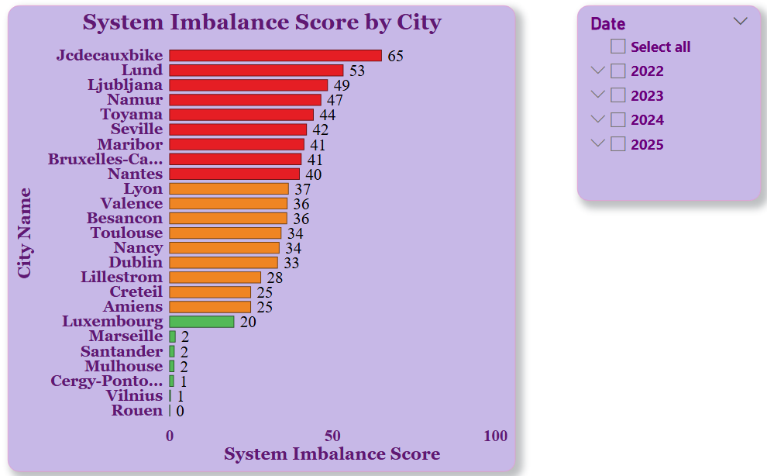
Station Status Breakdown by Station Size:
- The Station Status Breakdown by Station Size chart reveals that Small stations are the most vulnerable to inventory issues, with nearly 40% reaching a "Critical: Empty" state.
- In contrast, Large stations maintain the highest efficiency, with over 75% of stations remaining in a "Healthy" operational status.
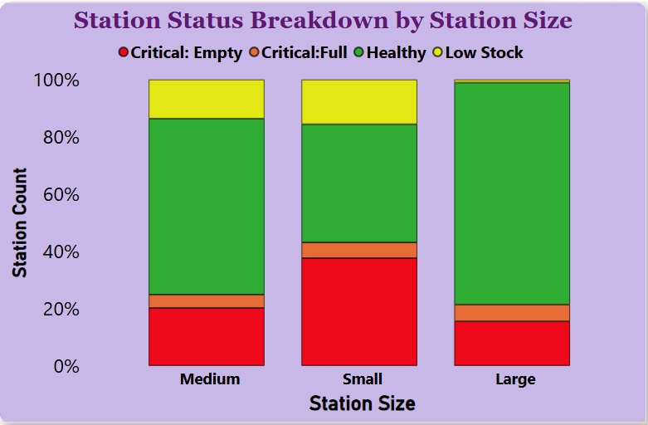
Available Bikes Vs. Total Capacity:
- Identification of Underutilized Infrastructure: Multiple data points fall significantly below the trend line, representing stations that are "Overbuilt" or "Critical: Empty". For instance, some stations with approximately 130 stands hold fewer than 60 bikes, suggesting wasted capacity.
- Conversely, several stations sit far above the trend line, such as a station with roughly 125 stands holding nearly 125 bikes. These represent "Critical: Full" risks where users may soon be unable to return bikes.
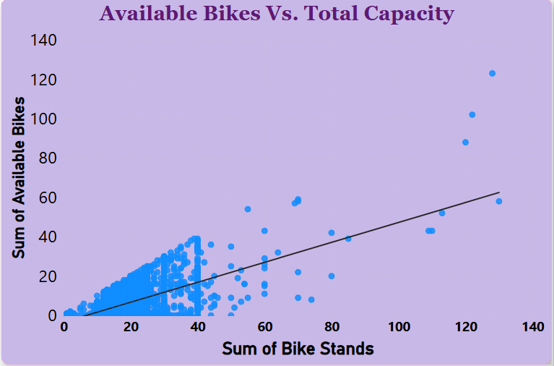

- Report
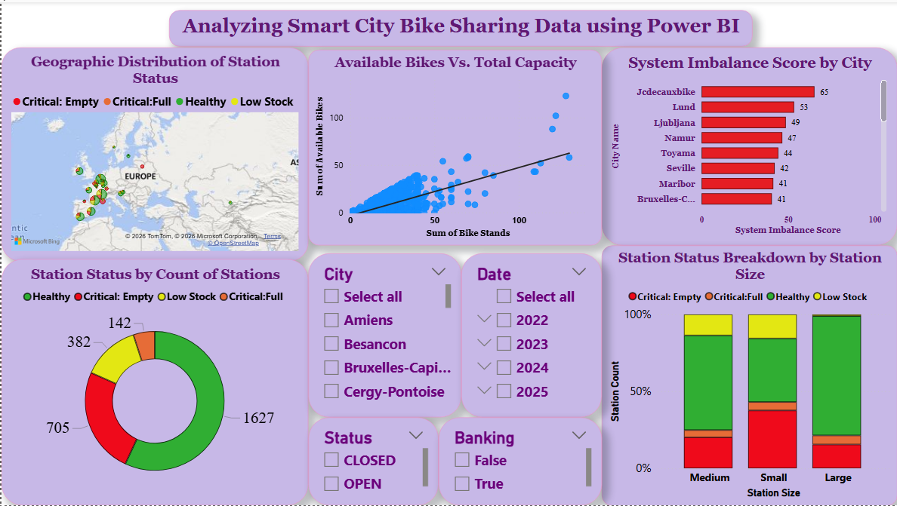
9. Insights & Conclusions
Key Findings
- Approximately 30% of the global network is in a "Critical" state, with 24.68% of stations being completely empty.
- There is a massive performance gap between cities; Marseille and Rouen maintain near-perfect balance (Score 0–2), while Jcdecauxbike and Lund suffer from extreme inefficiency (Score 53–65).
- Small stations are the most fragile, with a 40% Critical: Empty rate, whereas Large stations are the most stable, with 75% remaining "Healthy".
- The scatter plot identifies significant "Overbuilt" outliers—stations with over 130 stands but fewer than 60 bikes available.
Analysis Insights
- Prioritize rebalancing efforts in cities with an Imbalance Score above 40 to move bikes from "Full" outliers to "Empty" clusters.
- For Small stations with high empty rates, consider physical expansion or implementing "Bonus" incentives to encourage users to return bikes to those specific locations.
10. Conclusions
The integration of Power BI proved effective for end-to-end data analysis, from raw data to visual reporting.

